Tomah Deanery Spring Gathering
Saturday, May 4, 2024
St. John the Baptist Catholic Church, 504 Enderby Street, Wilton WI
Program begins at 9:00 a.m. (Registration from 8:45 to 9:00)

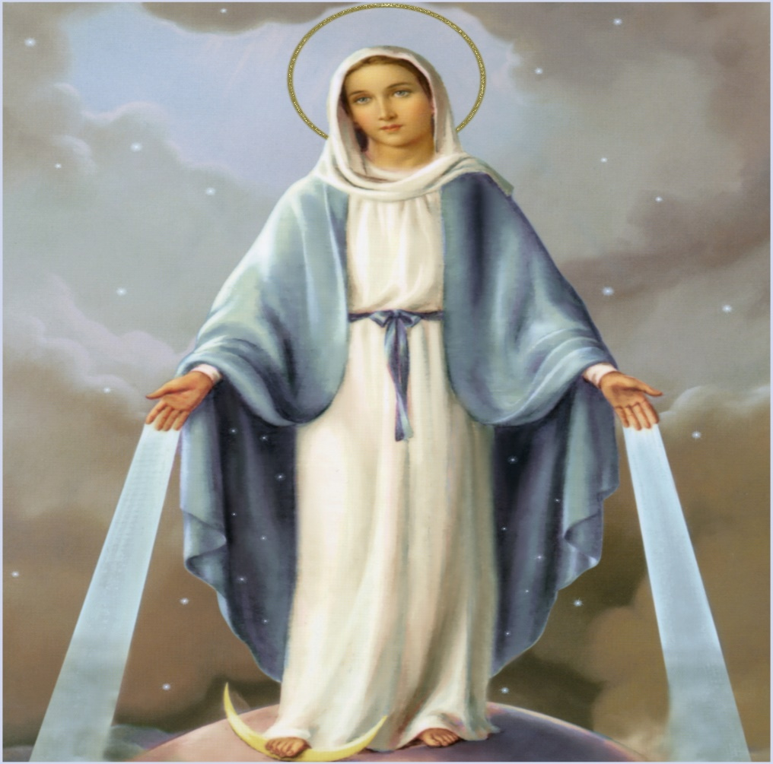
This Photo by Unknown Author is licensed under CC BY
Come help us celebrate the Month of Mary at the Tomah Deanery Spring Gathering on Saturday, May 4, 2024
Bring your rosary with you as we will be saying the rosary as part of our program.
We will have a speaker from Family Promise of Monroe County

